1. Open azure portal <https://portal.azure.com> & login
2. Connect & log into to window vm ( refer earlier documents )
3. Open [https://dev.azure.com/{your-org-name}/](https://dev.azure.com/%7byour-org-name%7d/)
4. Click on Organization Setting 🡪 Pipelines 🡪 Agent Pools 🡪 Add Pool

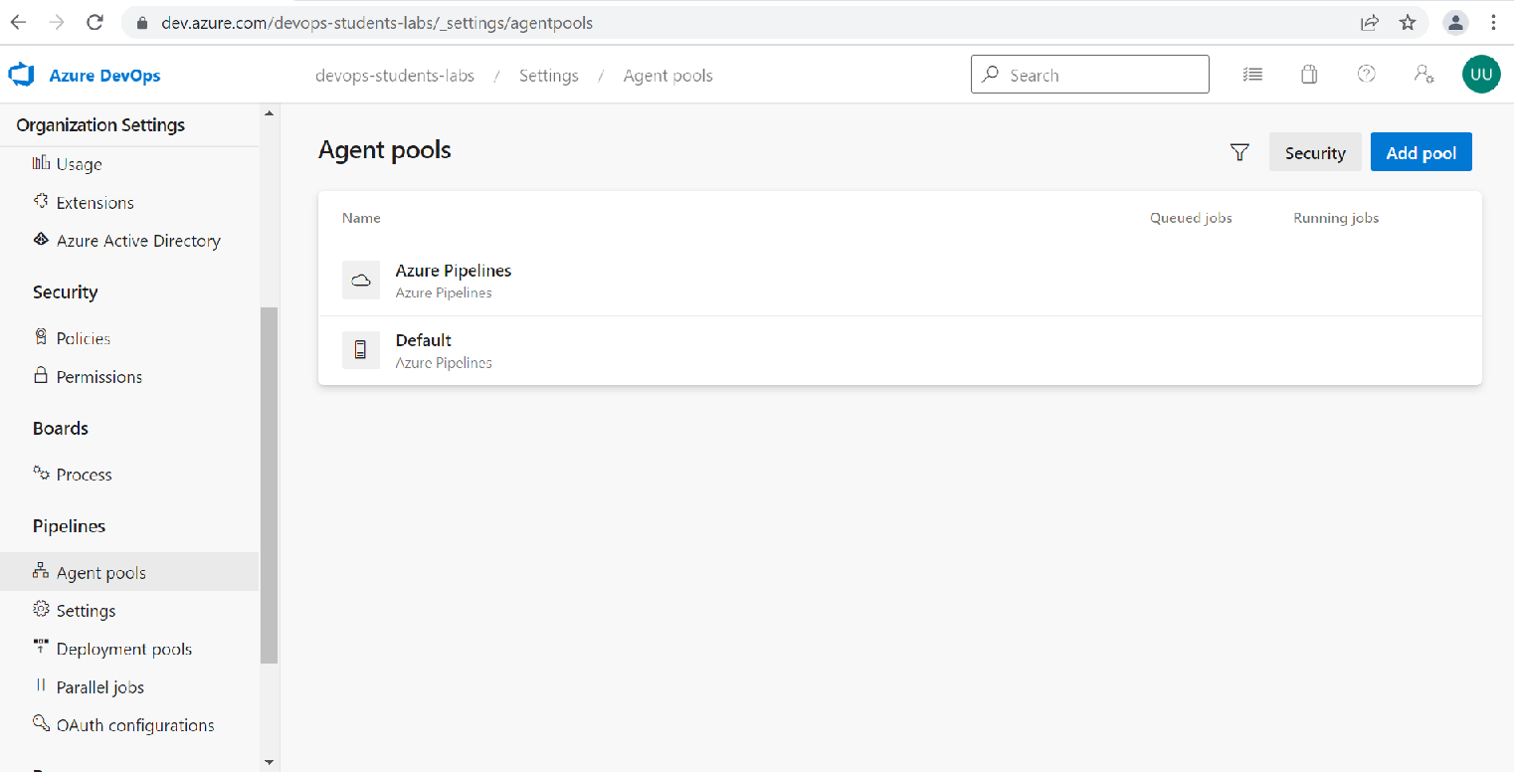

1. Click Pool type & select Self hosted and Name text box type your name of pool in this case self-hosted-window-pools & click on Create button
2. Click on New Agent 🡪 Windows 🡪 Download this will download zip file in your download folder

1. Open command prompt & go to C:\
2. Create folder agent and cd agent folder

1. Extract agent files in download folder & copy to newly created agent folder

1. Go to cmd and run config.cmd command
2. Enter your organization url as server name e.g. [https://dev.azure.com/{name-of-org}](https://dev.azure.com/%7bname-of-org%7d)
3. Click on User Setting 🡪 Personal Access Token 🡪 click on + symbol Graphical user interface, text, application, email

   Description automatically generated
4. Type agent name 🡪 custome defined scope 🡪 Show more scope 🡪 Agent Pools 🡪 Read & manage 🡪 Click

1. Copy personal access token & go back to cmd and paste pat 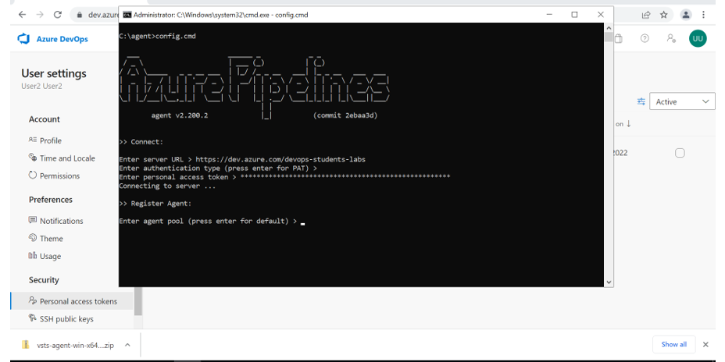
2. Give agent pool name previously created
3. Type agent name anything you like & all other option choose default

1. To run agent type run.cmd on command prompt Text

   Description automatically generated
2. Click on Oraganization Setting 🡪 Pipeline 🡪 Agent pools 🡪 self-hosted-window-pools & confirm your agent is online

